INTERNAL LAB EXAM

CREATE DATABASE & TABLE
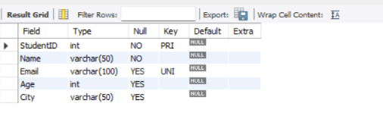

INSERT RECORDS
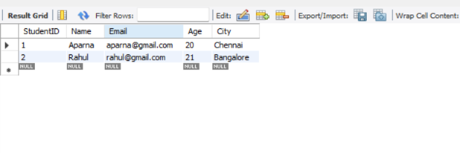
GROUP BY & HAVING
